HAWTHORN MEDICAL PRACTICE
MEETING Notes
Meeting Name: | Patient Participation Group
Date of Meeting: 9th April ‘25 | Time: 11:00am to 12:00 noon
Attendee Names: | Position:
Wendy Brady | Quality & Compliance Manager
JL | Group Member
CG | Group Member
LG | Group Member
Chair: | Minutes Taker:
Apologies/Absent:
CD

AGENDA:
ITEM 1: Notes from last meeting
Mins from the last meeting agreed.
F does not want to be a virtual member at present, Harold (applied to be a member, but is at school) would like to be a virtual member.
The “bat phone” is working again

ITEM 2: ICB – Quality Early Warning System
WN explained the QEWS document that the Practice has to complete for the ICB, the first section “Safe” had to be completed by 31.3.25. This has been done and the ICB on first inspection thinks we will score high. WB mentioned that the document does cover the same domains as CQC, however the ICB will not share the document with CQC.
The next section to be completed is “Well Led”
Actions:
ITEM 3. New Staff
WB informed the group of new staff members, we have a new Receptionist and a new Nursing team, following leavers and retirement, Michelle (Shelly) is the new receptionist.
Nursing Team as follows, Sophie, Polly, Michelle, Hannah, Anais and Chris
ITEM 4 Patient Survey
The patient survey was discussed, WB has downloaded the national survey and has briefly compared with the last in-house survey, carried out Oct/Nov ‘23
We are due to undertake another survey and the group will discuss at the next meeting, WB will bring the results of the National Survey
LG mentioned some negative comments on “google”, LG shared this information, WB to look into the comments and see if we have the chance to reply
Action:
WB to collate results of the last 2 surveys and bring to the next meeting.
WB to look at negative comments.
AOB
- L gave feedback from two patients having travel vaccines, the experience was very good from filling in the questionnaire to having the vaccines.
- Blood results were discussed again, WB mentioned a new tracking system, allowing the Practice to make sure all results are received back to the Practice.
- WB to check and see if patients can book Clinical Pharmacist appointments in advance
- WB mentioned the new system for on-line consultations, its no longer “e-consult” the new system is part of the clinical computer system, SystmOne, the form to complete should be slightly easier. Its called Systmconnect
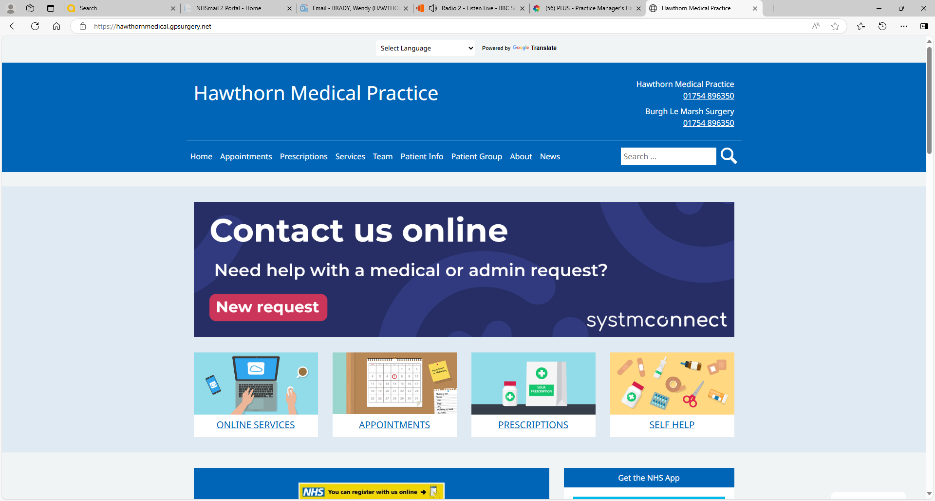
Actions;
- WB to find out about booking in advance for Clinical Pharmacists.
DATE OF NEXT MEETING: 28th May 2025 at 11am

